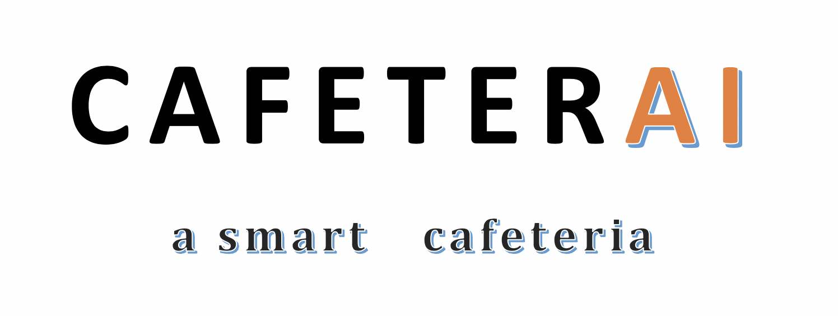

Cafeteria is an object detection and face recognition project which allow students to automatically buy food from the cafeteria.

Cafeteria recognizes your face from a previously saved database and detects which objects are on your plate and automatically deducts the money from your account. The project allows students to enjoy their lunch rather than waiting in long lines for their food.

**Meeting dates**

Every Thursday after school till 4:45 and Mr. Hatcher’s room.